|  |  |
| --- | --- |
| EGC_Black | **MATHEMATICS:SPECIALIST UNIT 3**  **TEST 2 2016**  **Calculator Free** |

Name: \_\_\_\_\_\_\_\_\_\_\_\_\_\_\_\_\_\_\_\_\_\_\_\_\_\_\_\_\_

Reading Time: 2 minutes

Total Marks: 40 marks Time Allowed: 40 minutes

**Question 1. (2 marks)**

Sketch the set of points z, in the complex plane, that satisfy the equation $\left|z-3i\right|= \left|z-3\right|$

|  |
| --- |
|  |

**Question 2. (4 marks; 2,2)**

Sketch, on the same set of axes below, the region in the complex plane defined by

a) $\left|z-1+2i\right|<1$

b) $\frac{π}{6} ≤ θ ≤ \frac{π}{3}$

**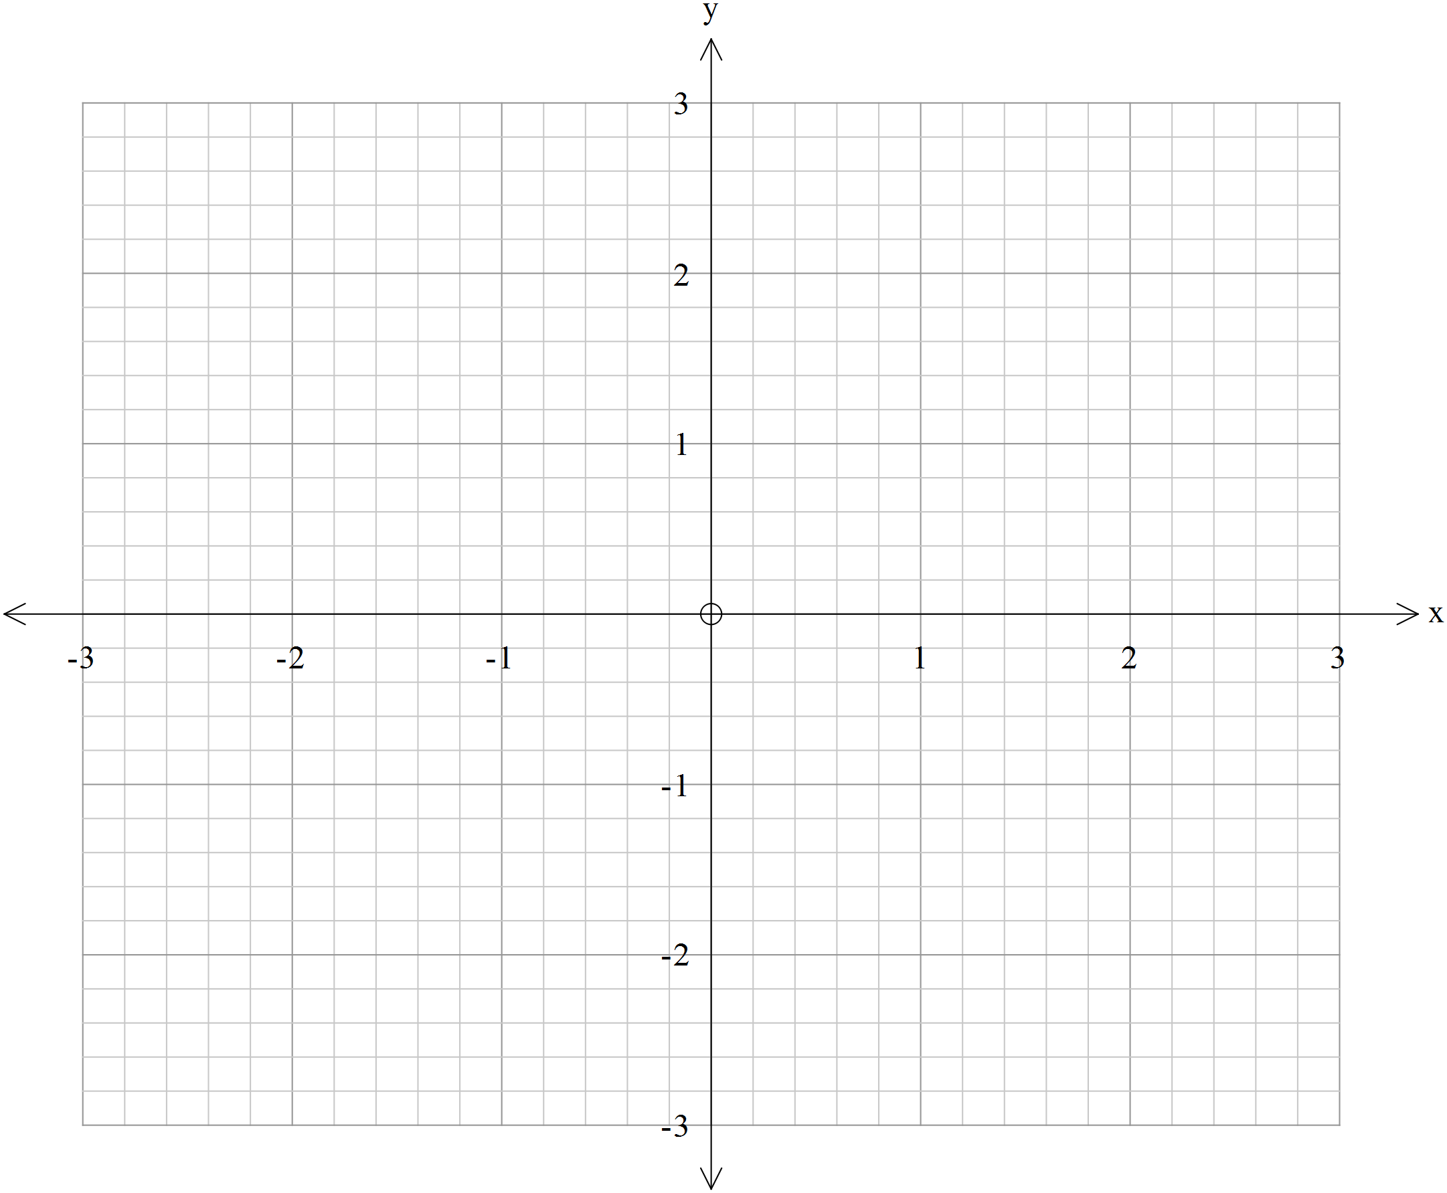**

**Question 3. (7 marks: 1, 1, 1, 1, 1, 2)**

Given that $z=3 cis \frac{π}{3}$ and $w=2 cis\left(-\frac{π}{4}\right)$ determine using $cis$ notation:

$z . w$

$\frac{z}{w}$

$i. w$

$\overline{w}$

e) $\frac{i}{z}$

f) Determine $Re (z+w)$ exactly.

**Question 4. (11 marks: 3, 2, 4, 2)**

a) Express  in the form a + bi where a and b are real numbers.

b) If (a + 5i) (2 - i) = b where a and b are real numbers, determine a and b

**Question 4.**

c) Given z =  and w = 

i) express z and w in polar form

ii) Find  in cartesian form.

**Question 5. (5 marks)**

The function f(x) = x3+ ax2 + bx - 2 has (x - 2) as a factor but a remainder of -6 is left when f(x) is divided by (x + 1). Find a and b.

**Question 6. (6 marks)**

Find all the real and complex roots of x3 + 3x2 + 3x + 2 = 0.

**Question 7. (5 marks)**

Evaluate (1 + i)7 + (1 – i)7 using de Moivre’s rule.

|  |  |
| --- | --- |
| EGC_Black | **MATHEMATICS:SPECIALIST UNIT 3**  **TEST 2 2016**  **Calculator Assumed** |

Name: \_\_\_\_\_\_\_\_\_\_\_\_\_\_\_\_\_\_\_\_\_\_\_\_\_\_\_\_\_

Reading Time: 2 minutes

Total Marks: 26 marks Time Allowed: 28 minutes

**Question 8 (5 marks; 1,4)**

One cube root of *z* is $\frac{5\sqrt{2}}{2}+\frac{5\sqrt{2}}{2}i$

a) Write z in exact Cartesian form.

b) State the other two cube roots of *z* in exact polar form.

**Question 9. (10 marks; 5, 3, 2)**

a) Determine all the roots of the equation $z^{6}= \sqrt{3}+i$, expressing them in exact polar form *r*cis $θ$

where *r $≥$* 0 and $-π < θ ≤ π.$

b) Sketch all the roots from (a) on the diagram below.

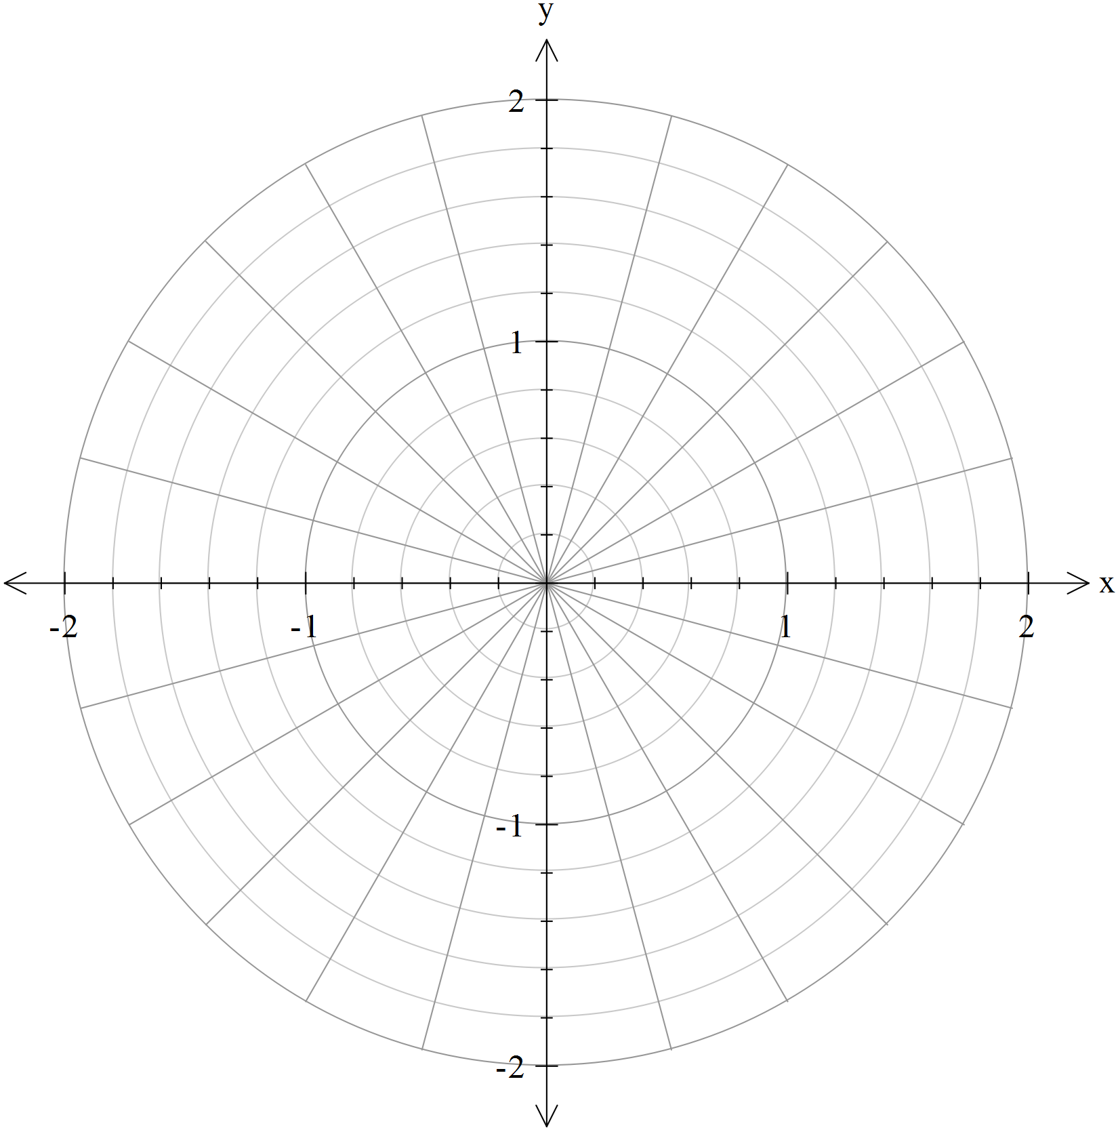

c) The roots form the vertices of a hexagon. Determine the exact value for the perimeter of the hexagon.

**Question 10. (6 marks; 2, 4]**

For $\left\{z : \left|z-(3+4i)\right|=2\right\}$ determine:

a) The maximum and minimum value of |*z*|

b) the maximum and minimum values of arg z.

**Question 11. (5 marks)**

Use the identity  to prove that .